Project 5: Automation and Change Governance (IaC for Network)

Nobody changes the production network by clicking in the AWS console. Every change is written as code, checked, approved, and applied by a pipeline.
- IaC (Infrastructure as Code): the network is described in files, for example Terraform or CloudFormation.
- Guardrails: automatic checks that stop unsafe changes before they go live.
- Pipeline: the only path to production, so every change is controlled.
- Audit trail: you can always see who changed what, when, and why.
- Your job: define the standards and guardrails for network changes.

Network diagram
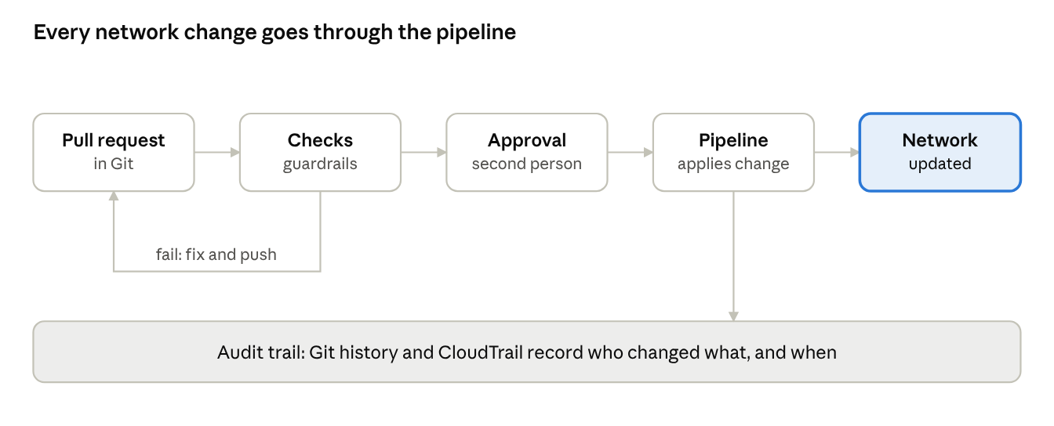
change pipeline · 5 steps, 1 loop back
A change that fails the checks goes back to its author. Only checked and approved changes reach the network, and every step is recorded.

IaC standards and guardrails
Standard | In simple words
Code lives in Git | Every network change starts as a pull request.
Shared modules | Teams reuse approved modules for VPCs, TGW attachments and routes.
Automatic policy checks | The pipeline rejects overlapping IP ranges and open-to-the-world rules.
Review and approval | A second person approves production changes.
Pipeline-only apply | People do not have write access to the network from the console.
Audit and drift checks | Git history and AWS CloudTrail record changes, and regular checks catch manual edits.

Production use case
Example scenario: a new app team needs a VPC connected to the Transit Gateway.
- The team opens a pull request using the approved VPC module.
- The pipeline checks the code. It finds that the IP range overlaps with another VPC and rejects it.
- The team picks a free range and pushes again. The checks pass.
- A network engineer approves. The pipeline builds the VPC, the TGW attachment and the routes.
- The change, the approver and the time are all recorded.
Result: a fast, repeatable change with no overlapping ranges and a full audit trail.

Interview questions and answers
Practice questions at the depth that senior cloud-network interviews at companies like AWS, Google and Meta expect. They are not official lists.
Q1. How do you make sure nobody changes the production network by hand?
Remove write access to network resources from people, and give it only to the pipeline role. Keep break-glass access that is logged and alerts the team. Run drift detection to catch anything that slips through.
Q2. How do you structure Terraform state for a large network?
Split state into small pieces (for example, per account or per layer) so one mistake has a small blast radius. Store state remotely with locking and encryption. Keep shared things like the Transit Gateway in their own state with tight access.
Q3. What is policy as code and what would you check?
Automatic rules run on every plan before apply. Examples: reject overlapping CIDRs, reject open-to-the-world rules, require tags, require encryption on flow logs. Tools such as OPA, Sentinel or cfn-guard do this.
Q4. A route change in production breaks traffic. How do you recover?
Roll back through the pipeline by reverting the commit. Keep changes small so the cause is clear. Have a documented emergency path for when speed matters, and review the incident afterwards.
Q5. How do you test network code before it reaches production?
Validate and lint, run policy checks, apply to a test account that mirrors prod, and then use Reachability Analyzer to prove the expected paths work and the blocked paths stay blocked.
Q6. How do you give many teams self-service without losing control?
Offer approved modules and let teams open pull requests. Guardrails check each change, and a network owner approves anything touching shared parts such as the Transit Gateway. Teams move fast inside safe limits.

